Calculating Approximations of Pi

## Circle Method

For the circle method, we need to make sure that we are all on the same page as to how we are going to calculate $π$. This requires us to know that the equation for the area of a circle is the following:

$Area = π ⋅r^{2}$

We can rearrange this equation so that we are instead solving for $π$, since $π$ will be the unknown that we want to approximate. Our new equation will look like this:

$π=\frac{Area}{r^{2}}$

Let us visualize what we have so far.

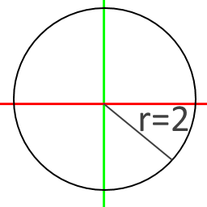

We made a circle at the origin (X axis is red, Y axis is green) and the radius we chose is 2. This was an arbitrary decision, however, you will see in a bit that by choosing 2 we can simplify this problem immensely.

So we have an area we need to find, highlighted in blue here.

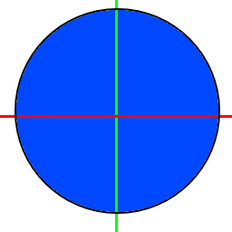

Finding the area of this is going to be really hard without knowing $π$ though (remember that we are pretending we don’t know what $π$ is in this assignment. It is what we are trying to approximate. Now we do know one of our variables, and that is the radius of 2. Let’s look back at the equation that we had earlier.

$π=\frac{Area}{r^{2}}$

If we replace r with 2, we get this:

$π=\frac{Area}{4}$

If we take a look at our circle centered on the origin again, we will notice that it is really easy to divide by 4:

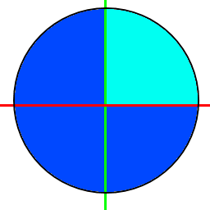

What this allows us to do is simplify our equation even more:

$π=Area$

So with that, we know that if we can find the area of this quarter circle, we will find $π$. Now let’s take a more in-depth look at our quarter circle and also recall pythagorean theorem.

$A^{2}+B^{2}=C^{2}$

This visualization helps me to understand what this really means.



Now we can approximate the area of the quarter circle by splitting it up into small rectangles, the height of which we can find using pythagorean theorem. Each rectangle has a fixed width and the height is chosen so that the circle passes through the midpoint of the top of the rectangle.

The idea is as we use more and more rectangles, we will get a closer and closer approximation of the area under the curve, which we already said was the same as $π$ in the case where the radius is 2.

Here are some images to visualize what I am talking about.

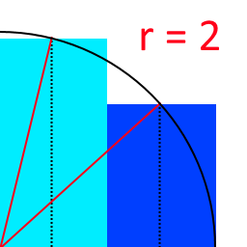

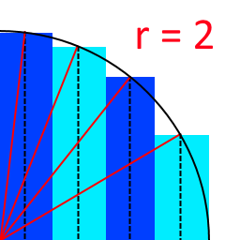

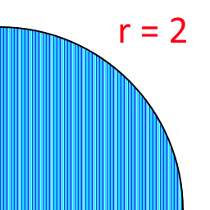

Note that the radius lines are not shown in the last image or it would be a real mess.

As the number of rectangles goes to infinity and the width goes to zero, we get the value for *pi*.

For each rectangle, the width, *w*, is the same, derived by dividing the radius of the circle by the number of rectangles. The height, *h*, on the other hand, varies depending on the position of the rectangle. Rectangles closer to the center of the circle will be taller than those near the edge. If the midpoint of the rectangle in the horizontal direction is given by x, then the height of the rectangle can be computed using the pythagorean theorem, also known as the distance formula when in this form:

$h=\sqrt{r^{2}-x^{2}}$

The sum of the areas of the rectangles provides an approximation to the area of the quarter circle, hence, it is also an approximation of pi. The more rectangles there are, the closer the approximation.

Here are some results, using a small number of iterations:

Approximations for pi  
Iterations Circle Method Leibniz Method  
----------------------------------------------  
 1 3.464101615138 4.000000000000  
 2 3.259367328636 2.666666666667  
 3 3.206412665814 3.466666666667  
 4 3.183929220612 2.895238095238  
 5 3.171987823613 3.339682539683  
 6 3.164766816537 2.976046176046  
 7 3.160012188321 3.283738483738  
 8 3.156686931298 3.017071817072  
 9 3.154254281272 3.252365934719  
 10 3.152411433262 3.041839618929

Using a lot of iterations:

Approximations for pi  
Iterations Circle Method Leibniz Method  
----------------------------------------------  
 1 3.464101615138 4.000000000000  
 10 3.152411433262 3.041839618929  
 100 3.141936857900 3.131592903559  
 1000 3.141603544913 3.140592653840  
 10000 3.141592998025 3.141492653590  
 100000 3.141592664482 3.141582653590  
 1000000 3.141592653934 3.141591653590

### **Pseudocode for finding the area under the quarter-circle:**

For each iteration:

1. Calculate the new midpoint
   * Don't use the previous value and add to it, this is what gives you too many rounding errors, resulting in incorrect output.
2. Calculate the new height based on the radius and midpoint.
3. Calculate the area of the new rectangle using height and width.
4. Add the area of the new rectangle to the total area.

If you are getting this output (incorrect marked in red):

Approximations for pi  
Iterations Circle Method Leibniz Method  
----------------------------------------------  
 1 3.464101615138 4.000000000000  
 10 3.152411433262 3.041839618929  
 100 3.141936857900 3.131592903559  
 1000 3.141603544913 3.140592653840  
 10000 3.141592998025 3.141492653590  
 100000 3.141592664486 3.141582653590  
 1000000 3.141592653923 3.141591653590

You are doing it incorrectly and accumulating too many rounding errors.

## Leibniz Method

There are many ways that we can find a good approximation for $π$. This is another one that is great for introducing beginning coders to iteration. Gottfried Wilhelm Leibniz is the person who discovered this way of approximating $π$. His method works like this:

$\frac{π}{4}=1-\frac{1}{3}+\frac{1}{5}-\frac{1}{7}+\frac{1}{9}-\frac{1}{11}+...$

Hopefully you see the pattern, and if you haven’t yet noticed, this is actually calculating $\frac{π}{4}$. We want to calculate $π$ however. Well we can just multiply each side of our equation by 4 to get the following:

$π=4-\frac{4}{3}+\frac{4}{5}-\frac{4}{7}+\frac{4}{9}-\frac{4}{11}+...$